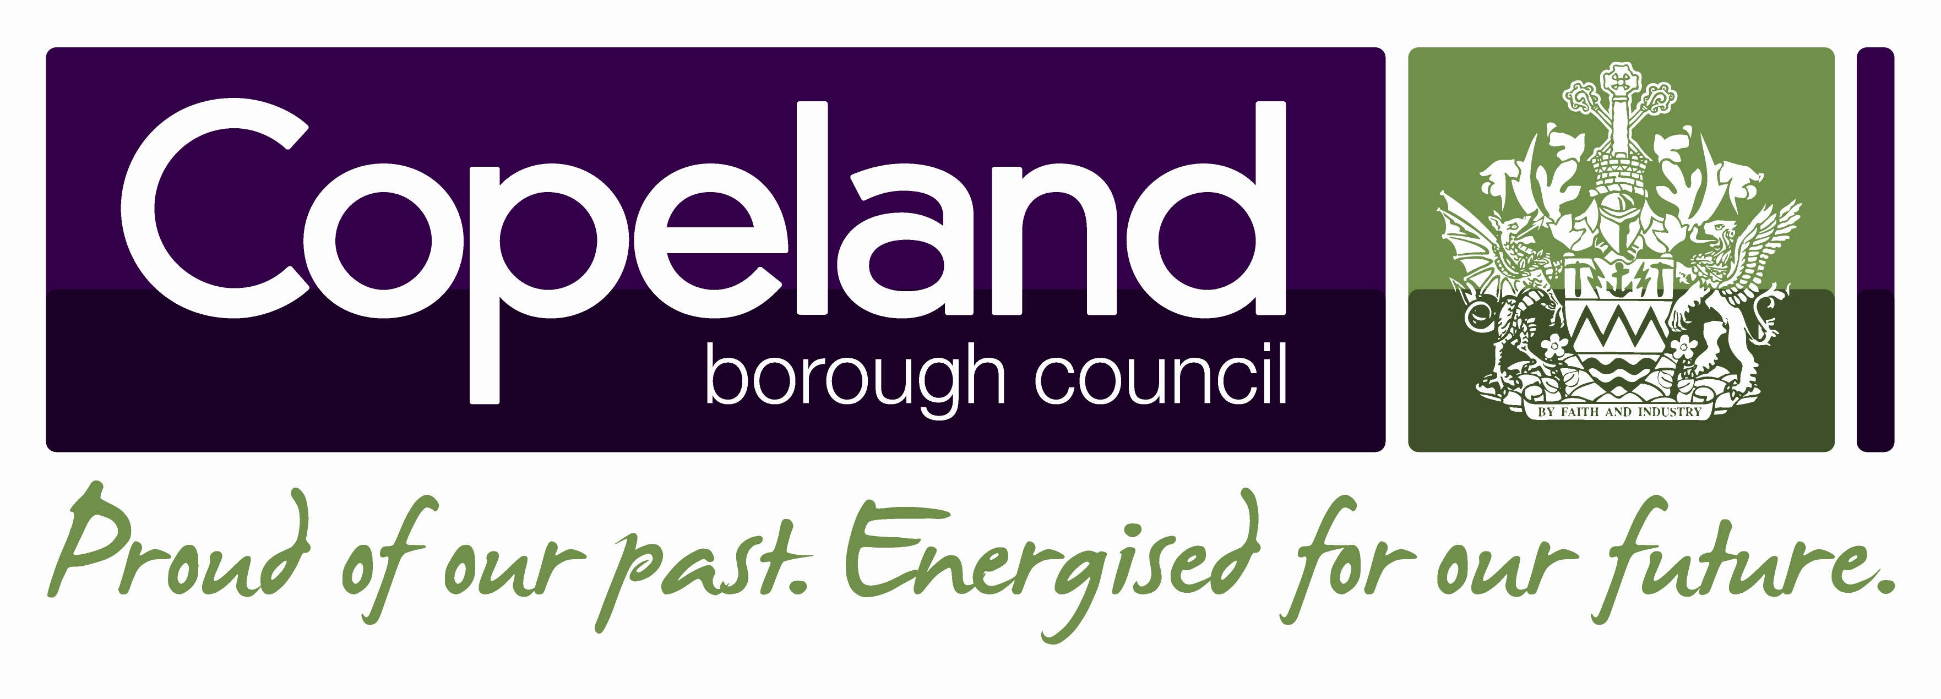 | Copeland Local Plan 2021- 2038
Focused Pre- Publication Draft Consultation
Response Form

This consultation response form provides the opportunity to comment on the Focused Pre-Publication draft of the Copeland Local Plan. This consultation outlines the most significant proposed changes that the Council is considering to make to the Preferred Options Draft of the Local Plan, which was consulted on in September 2020.

The Focused Consultation includes proposed changes that are considered to be significant, including draft settlement boundary amendments, draft changes to site allocations and new or revised policies. All changes, including minor changes, will be included in the Publication Draft, which will be subject to a formal, 6 week public consultation under Town and County Planning (Local Planning) Regulations 2012 Regulation 19.

This form should be viewed alongside the draft Consultation Document and used to make any comments or recommendation.

Please return this form by no later than Sunday 17th October 2021 to:
For internal use:

Resp. No. ..........................

Rep. No. ..........................

Date Rec. ..........................
Strategic Planning  Copeland Borough Council  Market Hall, Market Place,  Whitehaven,  CA28 7JG | Strategic Planning  Copeland Borough Council  Millom Library  St George’s Road  Millom LA18 4DD
Or email: localplanconsultation@copeland.gov.uk

- Your Details
Please provide your details below. This information will be added into our database so we can contact you about future Local Plan consultations. All information in the following table will be used solely for this purpose and no identifying information will be used in any future stages of the Local Plan process. Age and gender data will be used to monitor engagement in the Local Plan consultation process. If you are using an agent we will use those details as our primary contact.

If you do not wish for your details to be held in our consultation database, please tick here:

 | Your Details | Agent’s Details (if applicable)
Name
Position
Organisation
Address
Postcode
Telephone
Email
Gender (Please circle)
Male | Female | Prefer not to say

Age (Please circle)
18- 25 | 26- 35 | 36-45 | 46-55 | 56-65 | 66-75 | 76+ | Prefer not to say

Privacy Notice
A copy of the Council’s privacy statement can be viewed at https://www.copeland.gov.uk/sites/default/files/attachments/privacy_notice1.pdf. Further information is also available by contacting the council’s Data Protection Officer at info@copland.gov.uk or by calling 01946 598300 and asking to speak to the Data Protection Officer.

2. Your Comments
Please state clearly the Draft Allocation, Settlement Boundary Extension change or Policy number to which your comment or recommendation relates. (Please continue on separate sheets if required)

Signature: |  | Date:

Please use a separate form for each site you wish to comment on and return this form no later than Sunday 17th October 2021. We are unable to consider any responses received after this date.

Thank you for completing this form

