  PAYMENT SLIP FOR GRANT OF PRIVATE HIRE VEHICLE LICENCE |  | Licensing &Land Charges  Environmental Health  Whitehaven Commercial Park  Moresby Parks  Whitehaven  CA28 8YD  Telephone: 01946 598519  licensing@copeland.gov.uk

ITEM DESCRIPTION CODE BARCODE FEE
Grant private hire vehicle licence - licence | 275112117 | ÊÃ:-UJk+51Å2tËÍ  9826135342751121172 | £117.00
Grant private hire vehicle licence - plate | 275112133 | ÊÃ:-UJk+5AÅ9ÄËÍ  9826135342751121339 | £8.00
TOTAL |  |  | £125.00

HOW TO PAY

Please choose one of the following payment options:-
- CHEQUE – please make your cheque payable to Copeland Borough Council and bring it with your application form and relevant documents to the address shown above.
- TELEPHONE PAYMENT – please telephone 01946 598300 with your debit/credit card details.

HOW TO PAY BY CASH  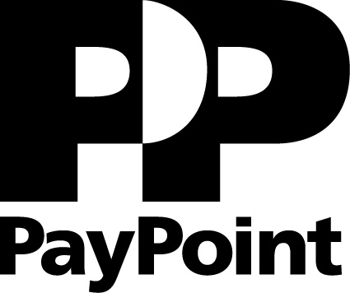

The Council does not have the facility to accept cash payments at any of its offices. However, if you prefer to pay your Licensing Application fees in cash please:-
- Take this form to any Post Office or Pay Point and make the required payment.
- Attach the original receipt to this form
- Include this form with your application and submit to the Council

Please note:
- You are advised to retain a copy of the receipt for your own records
- Failure to submit a receipt with this form will lead to a delay in providing the required documents and may, in exceptional circumstances, mean you have to repay the fee

Please do not hesitate to call the Council on 01946 598300 if you require any further information or assistance to enable you to pay any of your Council bills.

VAT Registration No. GB 257 1772 43

