

GENERAL PROCEDURE FOR OBTAINING DBS CERTIFICATE
This MUST be done using a computer or laptop (mobile phones will not load the application).
- The applicant can apply for their DBS certificate online at; www.personnelchecks.co.uk/taxis/copeland and make the £54.49 payment online.

- Payment £54.49 will be taken and an email sent to the applicant giving them details of how to complete the online application. The email will include a username and password so the applicant can log into the system and complete the application.

- Alternatively, the applicant telephones Personnel Checks on 01254 355672.
- Personnel Checks will email the applicant the contact details of the appropriate Council department so that they can make an appointment to have the required identification documents verified by an employee of the Copeland Licensing Department.
- Next you will need to email the Copeland Licensing Department at licensing@copeland.gov.uk or call on 01946 598519/ 01946 598521 / 01946 598517 to arrange an appointment. PLEASE NOTE THAT TAXI APPOINTMENTS ARE HELD ON TUESDAY MORNINGS ONLY.

You will need to submit your 3 forms of identification, plus your driving licence check code (see attached; a list of valid ID documents & instructions on how to obtain your check code), together with your completed application form, payment of £150 licence fee by either cheque or barcode payment + receipts, medical and 2 x passport size photographs of yourself.
The Licensing Team will then verify your Identity documents with Personnel Checks.
- Once your documents have been verified, Personnel Checks will then send you an email confirmation with the tracking number for your application.

- When the DBS Certificate is received from Personnel Checks you should again email or call the Licensing Department and arrange an appointment to bring the DBS certificate in to be assessed as part of your application.

LIST OF VALID IDENTITY DOCUMENTS – PERSONNEL CHECKS
Group 1 – Primary Trusted Identity Credentials:
- Current Driving Licence Photo Card (UK/Isle of Man/Channel Islands and EU)
- Current Valid Passport
- Birth Certificate issued at time of Birth (UK)
- Biometric Residence Permit (UK)
- Adoption Certificate (UK)
Group 2a – Trusted Government State Issued Documents
- Current Driving Licence Photo Card (All other countries)
- Old Style Paper Driving Licence (UK/Isle of Man/Channel Islands and EU)
- Birth Certificate – issued after time of Birth (UK & Channel Islands)
- Marriage/Civil Partnership Certificate (UK)
- HM Forces ID Card (UK)
- Fire Arms Licence (UK/Channel Islands and Isle of Man)
Group 2b – Financial/Social History Documents
- Mortgage Statement (UK or EEA) (issued in the last 12 months)
- Bank/Building society Statement (UK or EEA) (issued in the last 3 months)
- Bank Building Society Account Opening Confirmation Letter (UK) (Issued in the last 3 months)
- Credit Card Statement (UK or EEA) (issued in the last 3 months)
- Financial Statement – eg pension, endowment, ISA (Issued in the last 12 months)
- P45 or P60 Statement UK – (Issued in the last 12 months)
- Council Tax Statement (UK) issued in the last 12 months
- Work Permit/Visa (UK) (UK Residence Permit)
- Letter of Sponsorship from future employment provider (Non-UK/Non-EEA only – valid only for applicants residing outside of the UK at time of application)
- Utility Bill (issued in the last 3 months)
- Benefit Statement – eg Child Allowance, Pension (issued in the last 3 months)
- A document from Central/Local Government/Government Agency/Local Authority giving entitlement (UK & Channel Islands – eg from the Department for Work and Pensions, the Employment Service, Customs & Revenue, Job Centre, Job Centre Plus, Social Security (issued in the last 3 months)
- EU National ID Card – must be valid
- Cards carrying the PASS accreditation logo (UK) – must be valid
- Letter from Head Teacher or College Principal (16-19 year olds in full time education – only used in exceptional circumstances when all other documents have been exhausted)

Instructions on how to generate a code or print your driving licence summary

- Go to the Gov UK website; https://www.gov.uk/

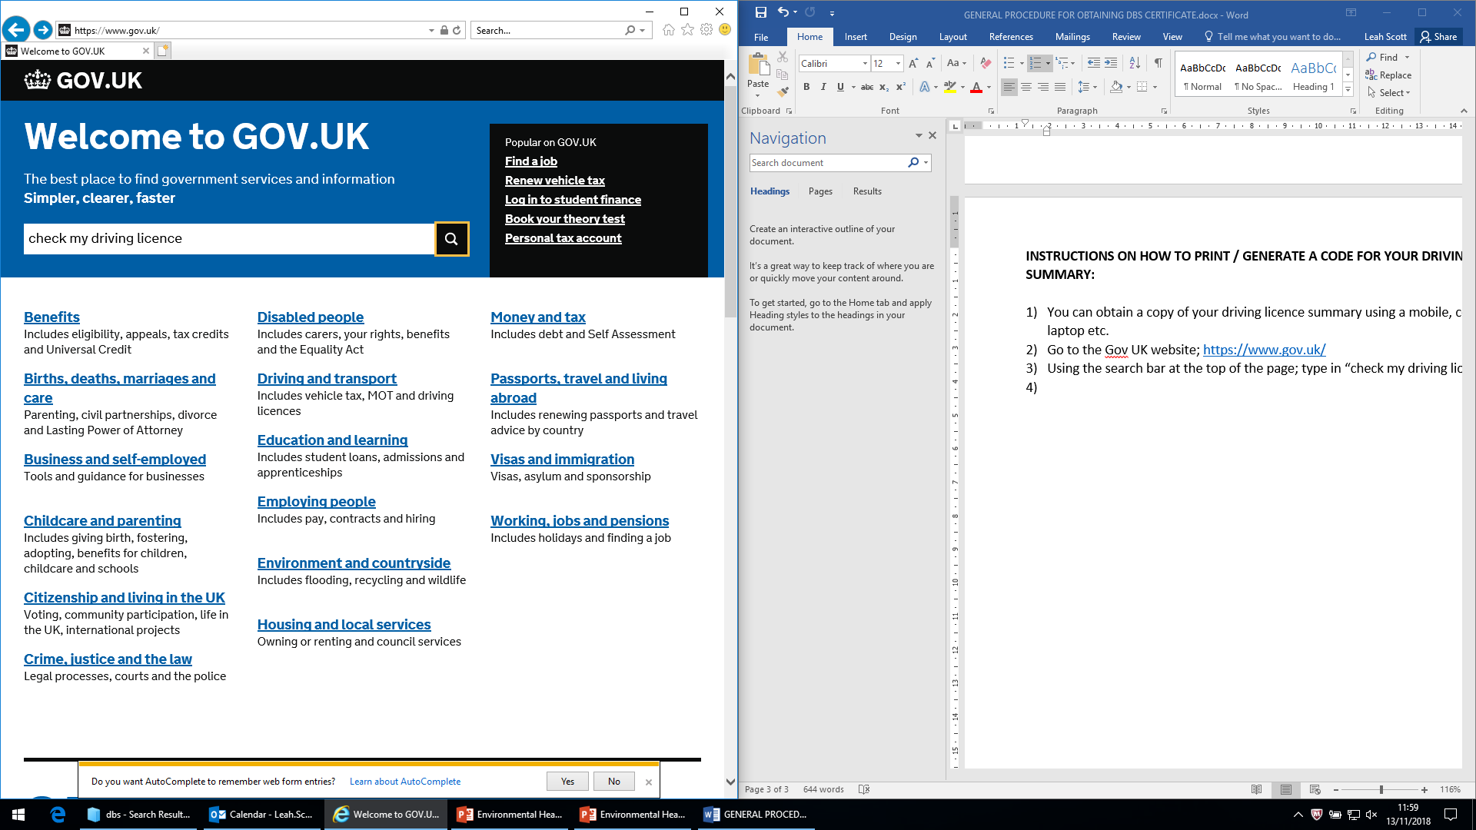
- Using the search bar at the top of the page; type in “check my driving licence” and press enter.
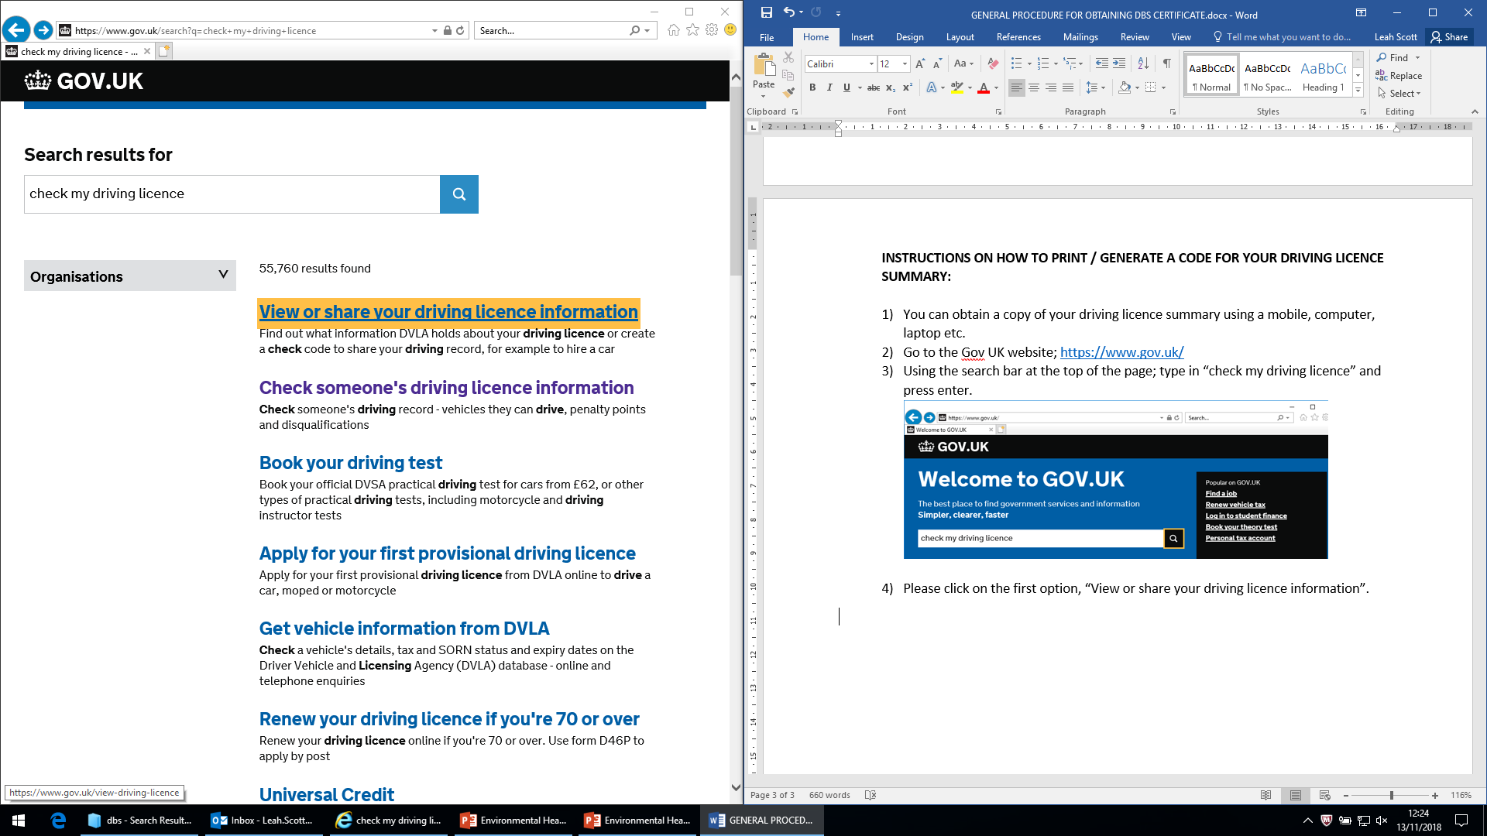
- Click on the first option, “View or share your driving licence information” and press enter.

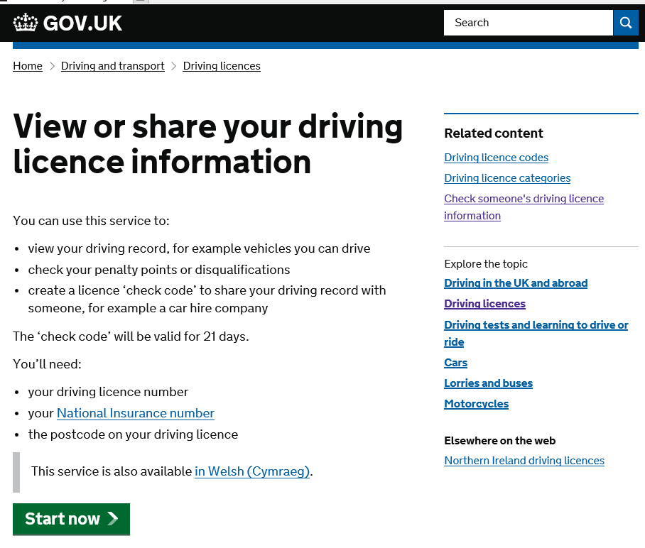
- The next page gives you the option to “View or Share your driving licence information”. Click on “Start Now”.

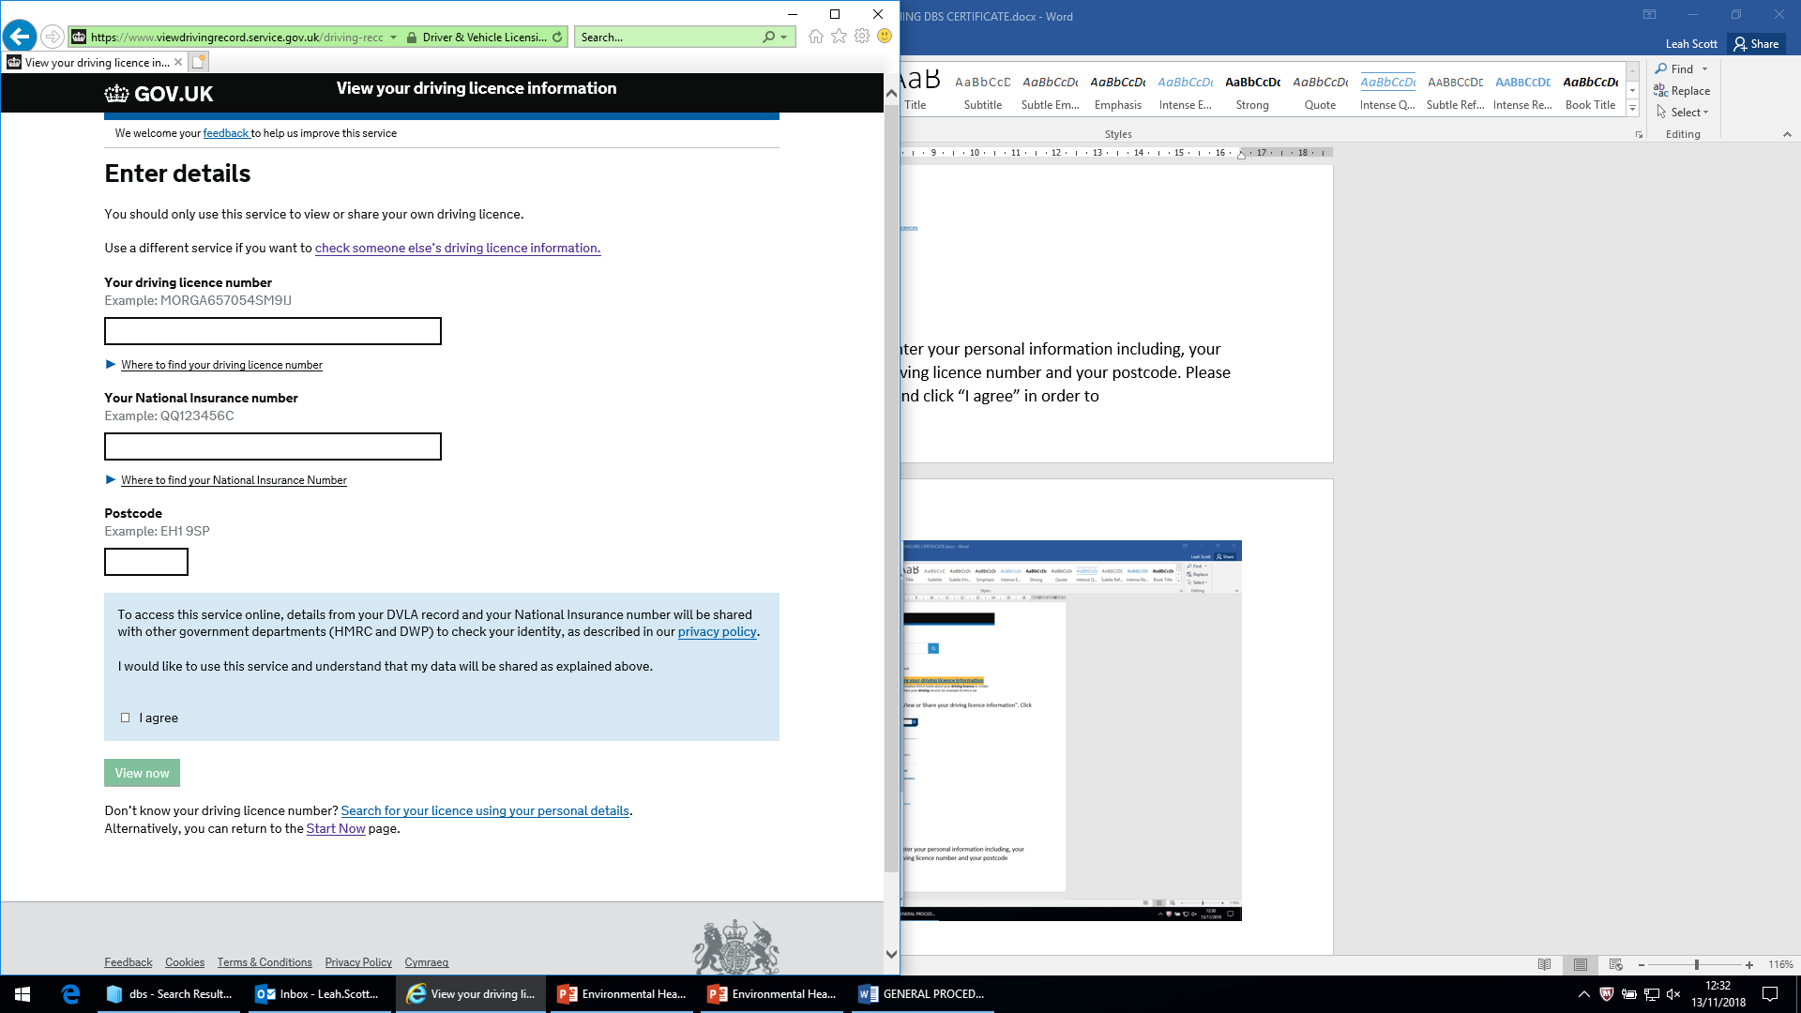
- On the next page you will need to enter your personal information including; your National Insurance number, your driving licence number and your postcode. Please read the paragraph in the blue box and click “I agree” and click on “View Now” in order to progress to the next screen.

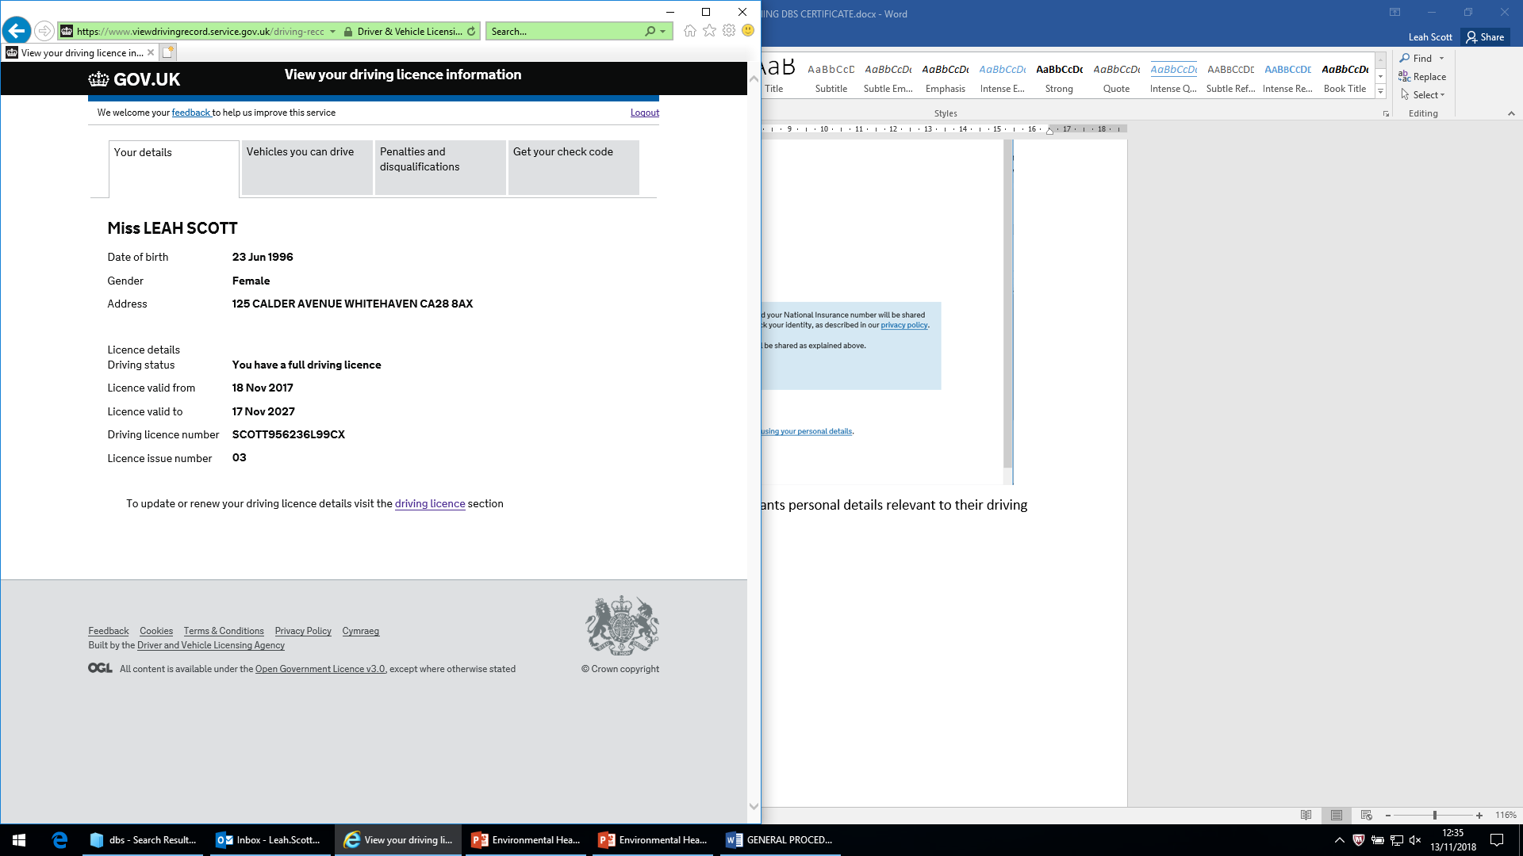
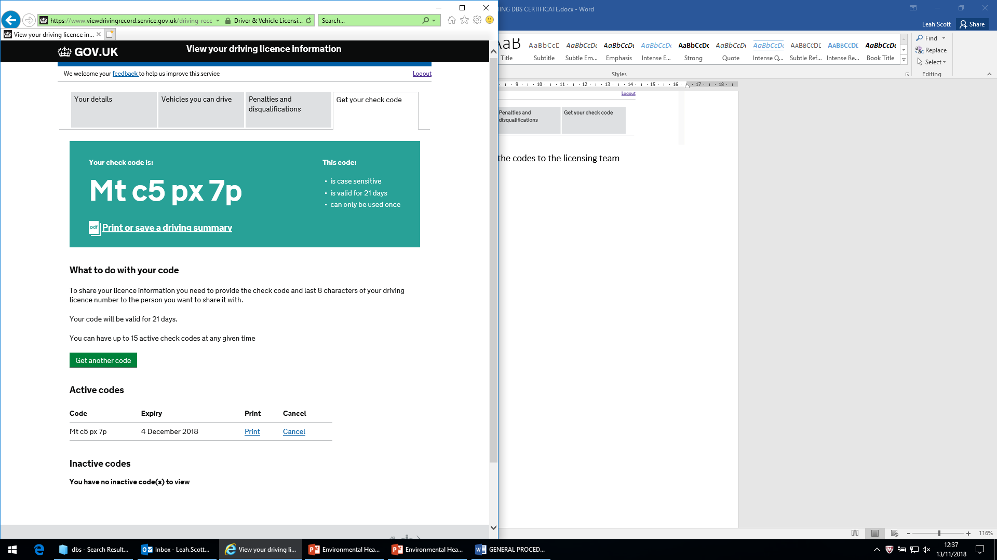
- The next screen will show the applicants personal details relevant to their driving licence. The applicant will need to click on “Get your check code”.

- When submitting your taxi badge application, you can generate a code to print the driving licence summary, this code can be emailed to the licensing department and printed at the Moresby office (the code will be unique to each individual).

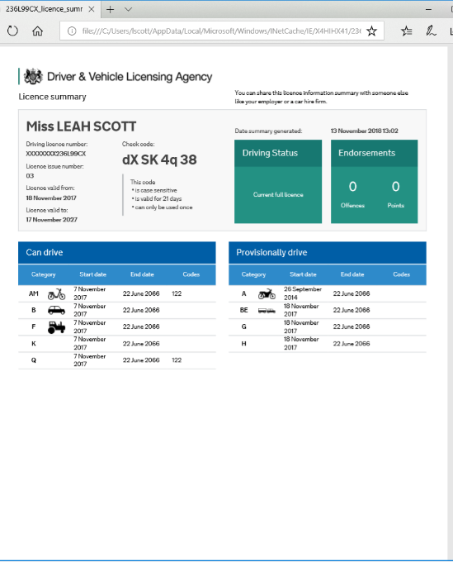
- You can also print or save a copy of your driving summary and hand it in with your application. The summary should be similar to the template on the right, where the summary is on one page, and should state your name at the top of the page.

